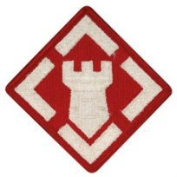 | 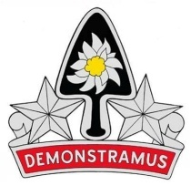 | 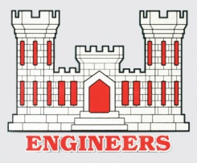

31st Engineer Battalion Combat Association Reunion
Colorado Springs, Colorado
October 5-8, 2017

The Veterans of the 31st Cordially invite you and yours to reunite, rekindle the bond of brotherhood and the stories of our service together and enjoy the tourist attractions and spectacular beauty of scenic Colorado Springs which ranks as one of the top ten Military Reunion Destinations.

LOCATION: Hotel Elegante Conference and Event Center, 2886 South Circle Drive, Colorado Springs, Colorado 80906 Website: http://www.hotelelegante.com.
AMENITIES: Free WiFi, free parking, free airport and area shuttle, Hotel restaurants (Rustler’s & Rawhide & Sweet Tooth), indoor and outdoor pool, Garden, casino shuttle, 24 hour fitness center, in downtown Colorado Springs, close to World Arena, Battlefield Colorado, Williams Fire Museum, World Figure Skating Museum etc. Visit the Colorado Springs Convention & Visitors Bureau website www.visitcos.com for tourist information.
ACCOMMODATIONS: A block of 65 rooms are reserved with a cutoff date of 18 August 2017 for individual reservations. Most of us can reserve a King or Double Queen bed for $109.00 plus 10.25% tax. See attached Page 3 for additional details on Room Blocks and occupancy rates. Complimentary breakfast for 2 adults included each day. Rates are available 3 days prior and 3 days after Reunion dates.
RSVP: For room reservations as soon as possible, but not later than 18 August 2017, by calling 800-981-4012. (Explain that you are with the 31st Engineer Battalion Reunion).
TENTATIVE AGENDA: See attached Page 2.
BATTALION WEBSITE: 31stengineerbattalion.com is ready for viewing, get updates on the reunion and past photos and postings. Webmaster - June Robbins, (941) 348-4925 junekeywest@yahoo.com. Please get to know the site and contribute information/photos if you wish.
POINTS OF CONTACT: Leonel (Leo) Farias, Director, (361) 815-7749, leofar41@gmail.com ; Warren Dubois,Treasurer, (573) 729-8157, dubois@embargmail.com.

